**Question-01**

**Task 1:**

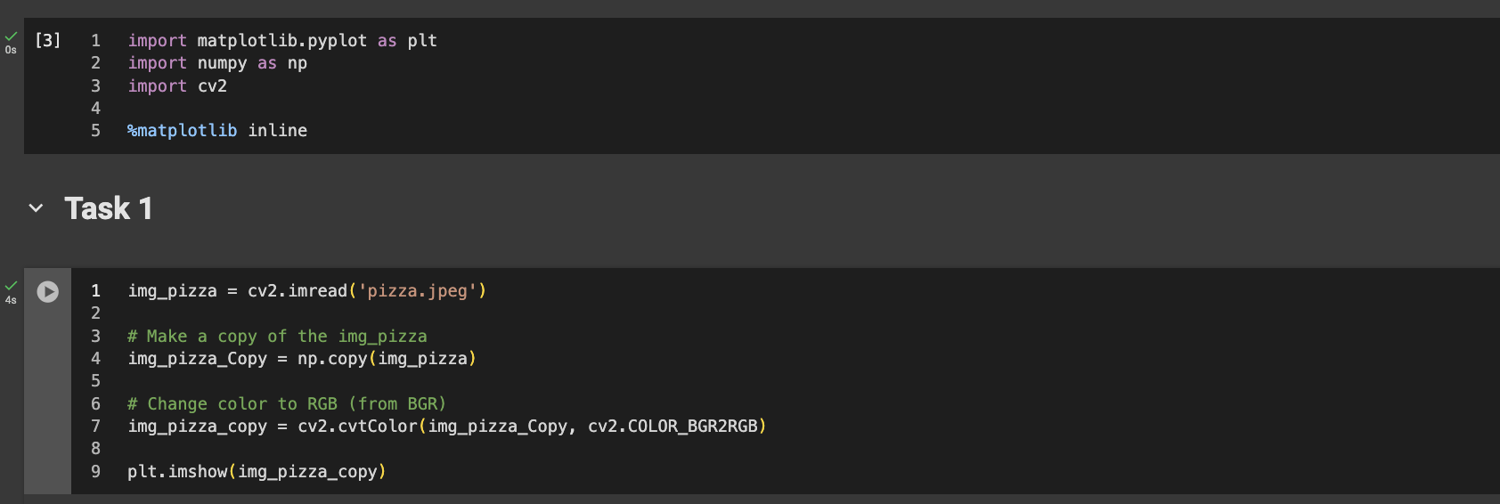

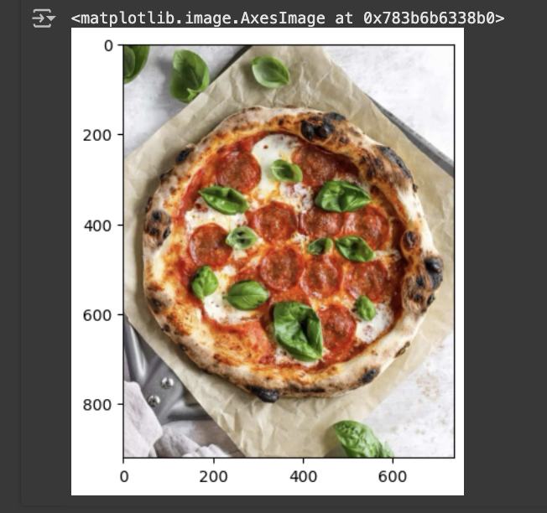

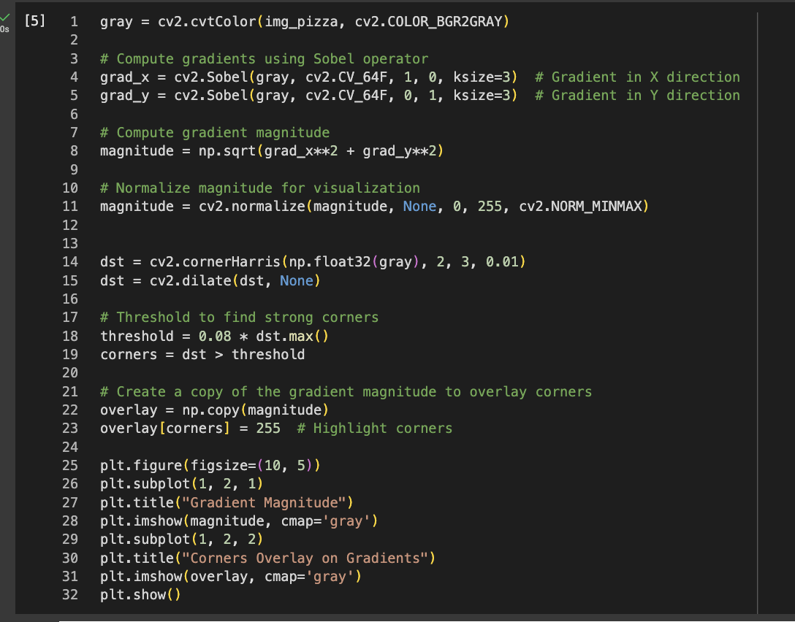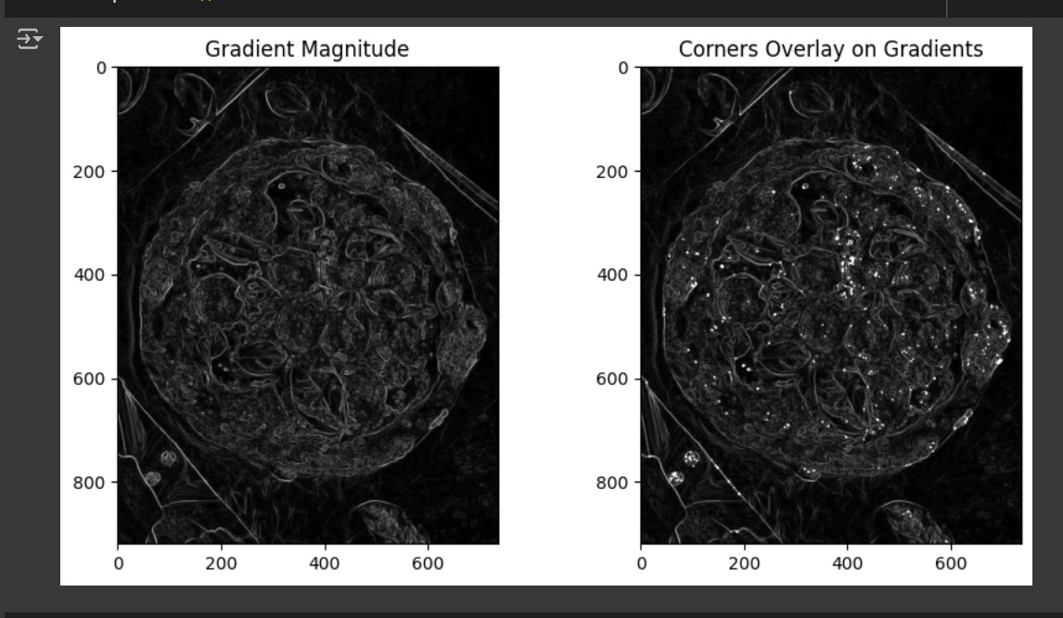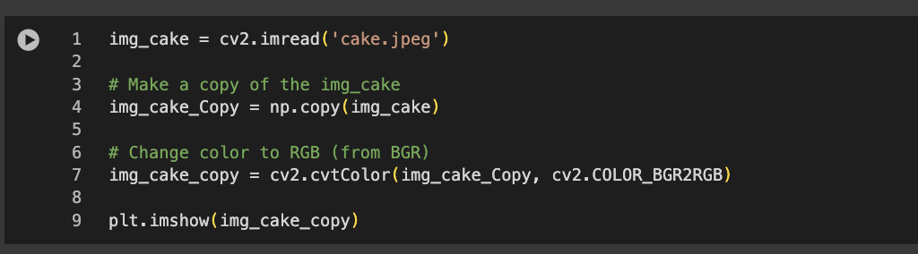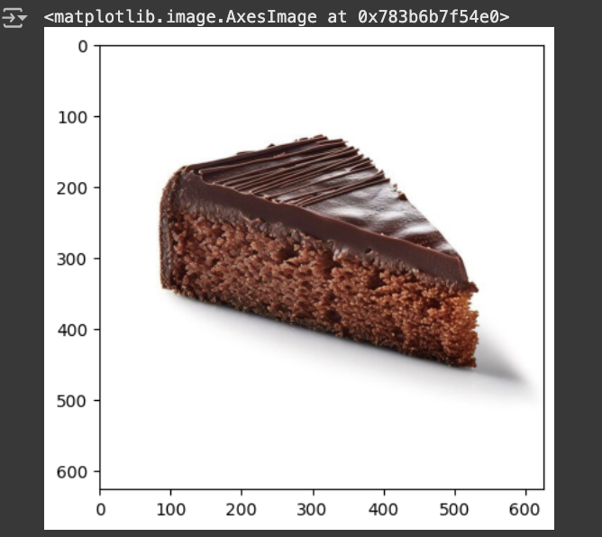

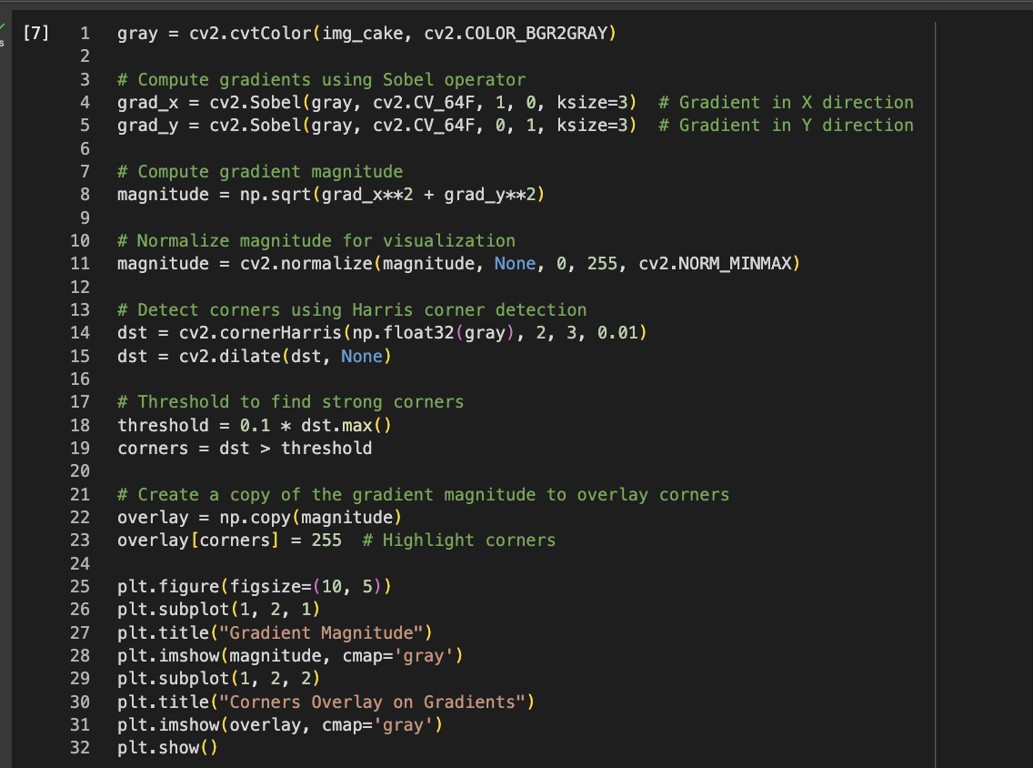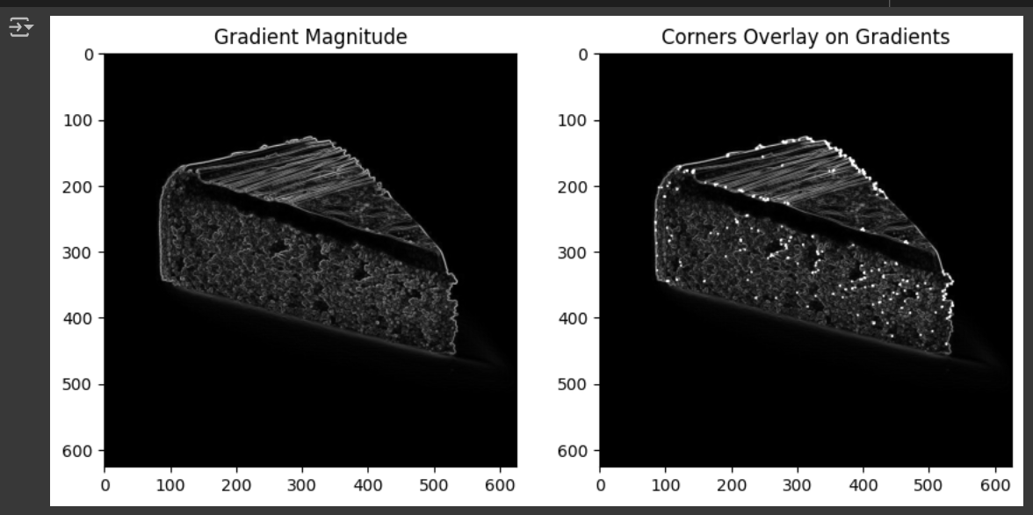

**Analysis:**

Harris Corner Detection struggles with circular shapes because their edges are smooth and don’t have sharp corners. Irregular textures like cheese or toppings create messy patterns that confuse the algorithm. Circles are often too symmetrical for it to find distinct corner points.

Replacing the circular shaped Pizza with a triangle-shaped cake piece we can see that, the Harris corner detection algorithm works better on triangle-shaped cake piece as the edges of a triange is more defined than a circular shaped Pizza.

**Question-02**

**Task 2:**

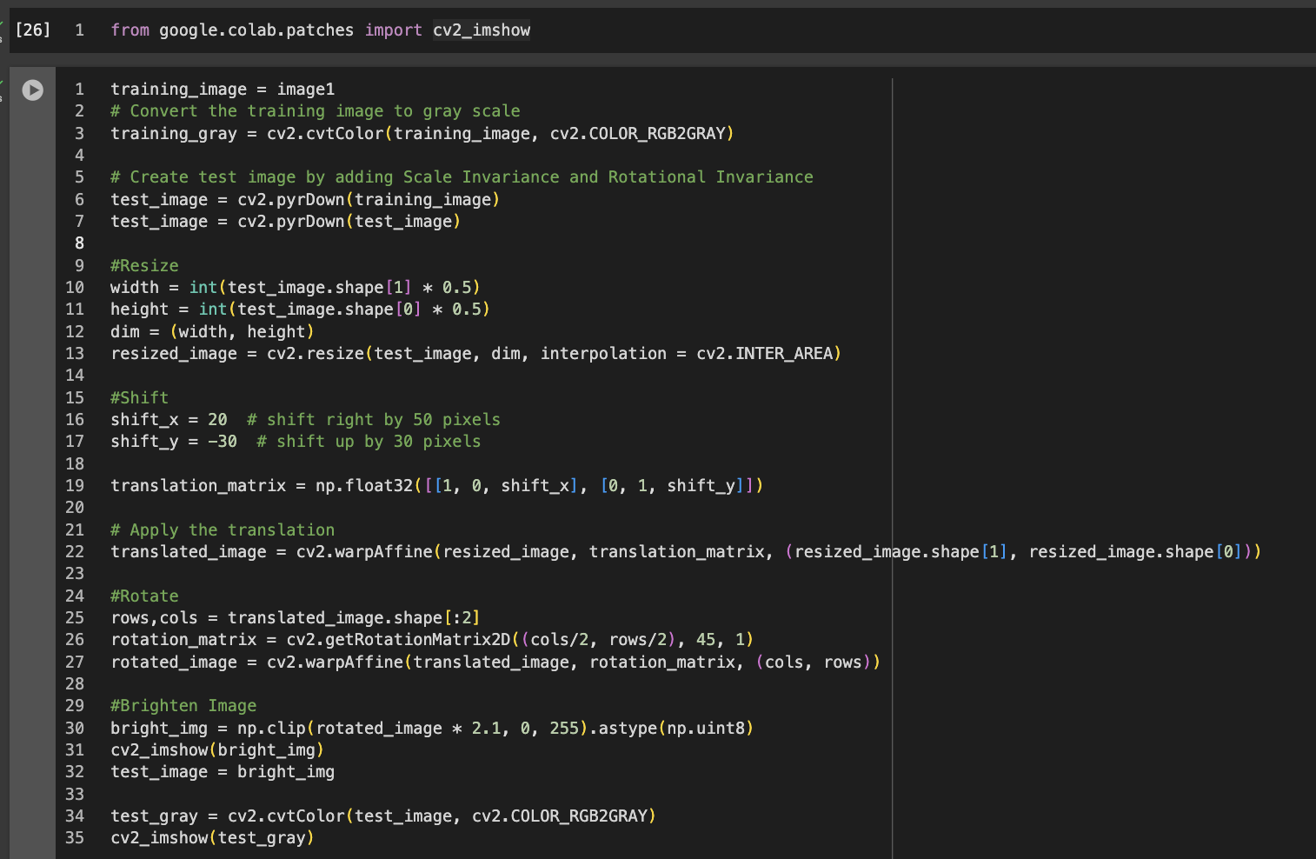

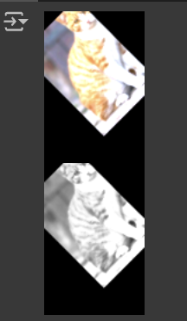

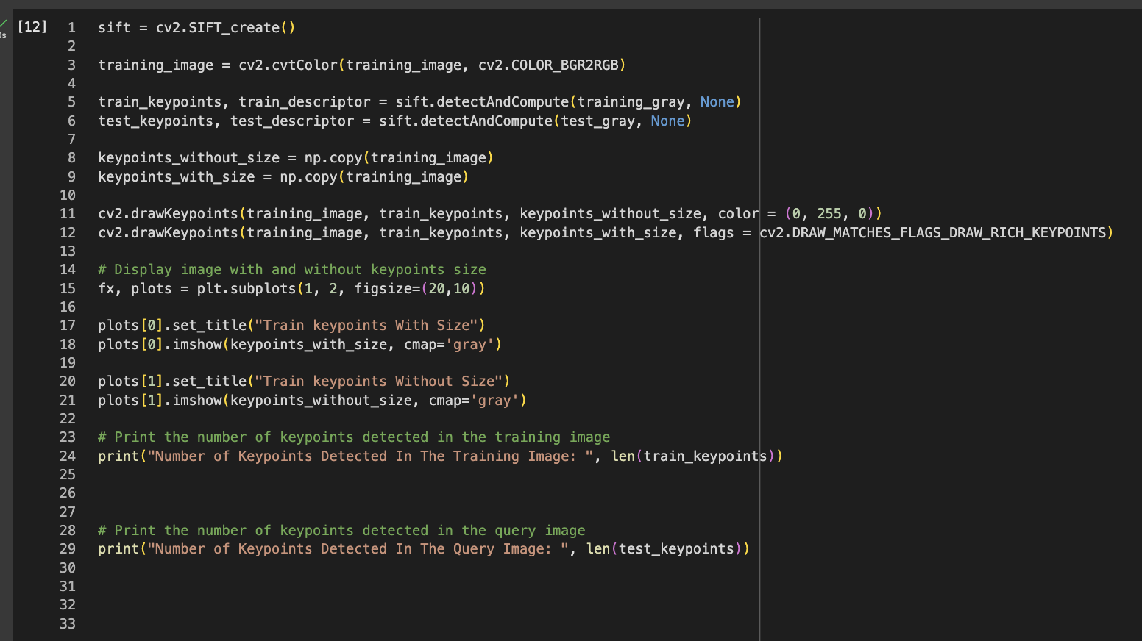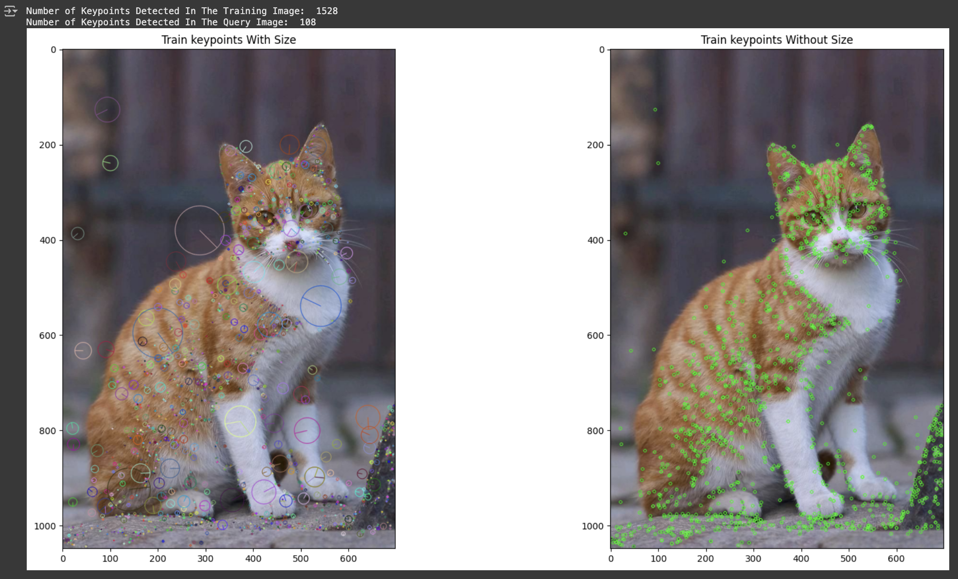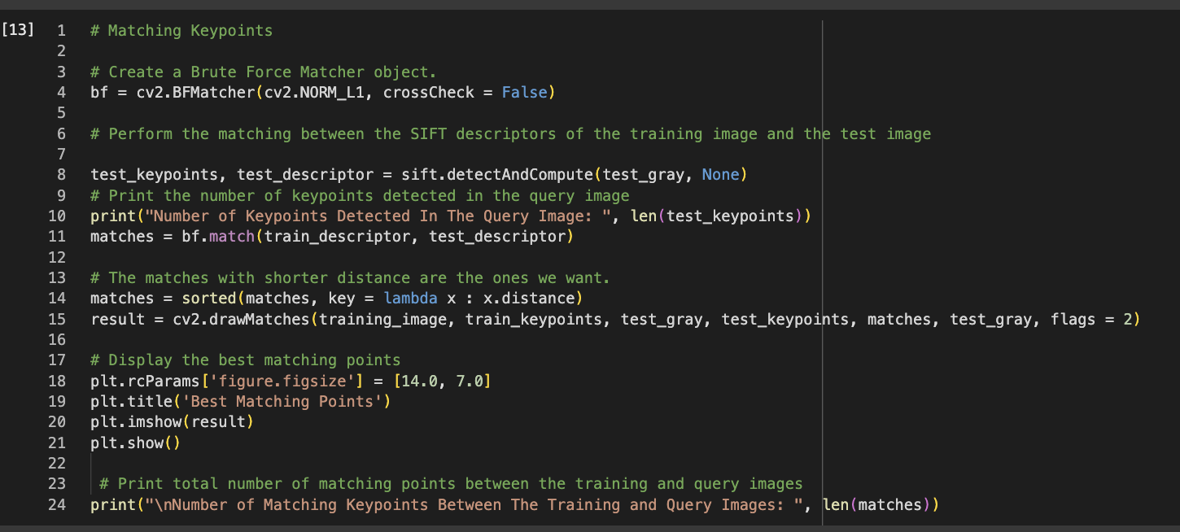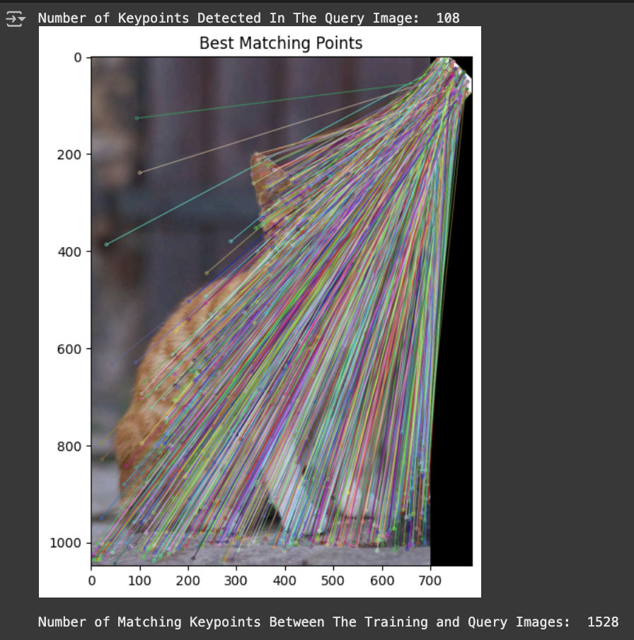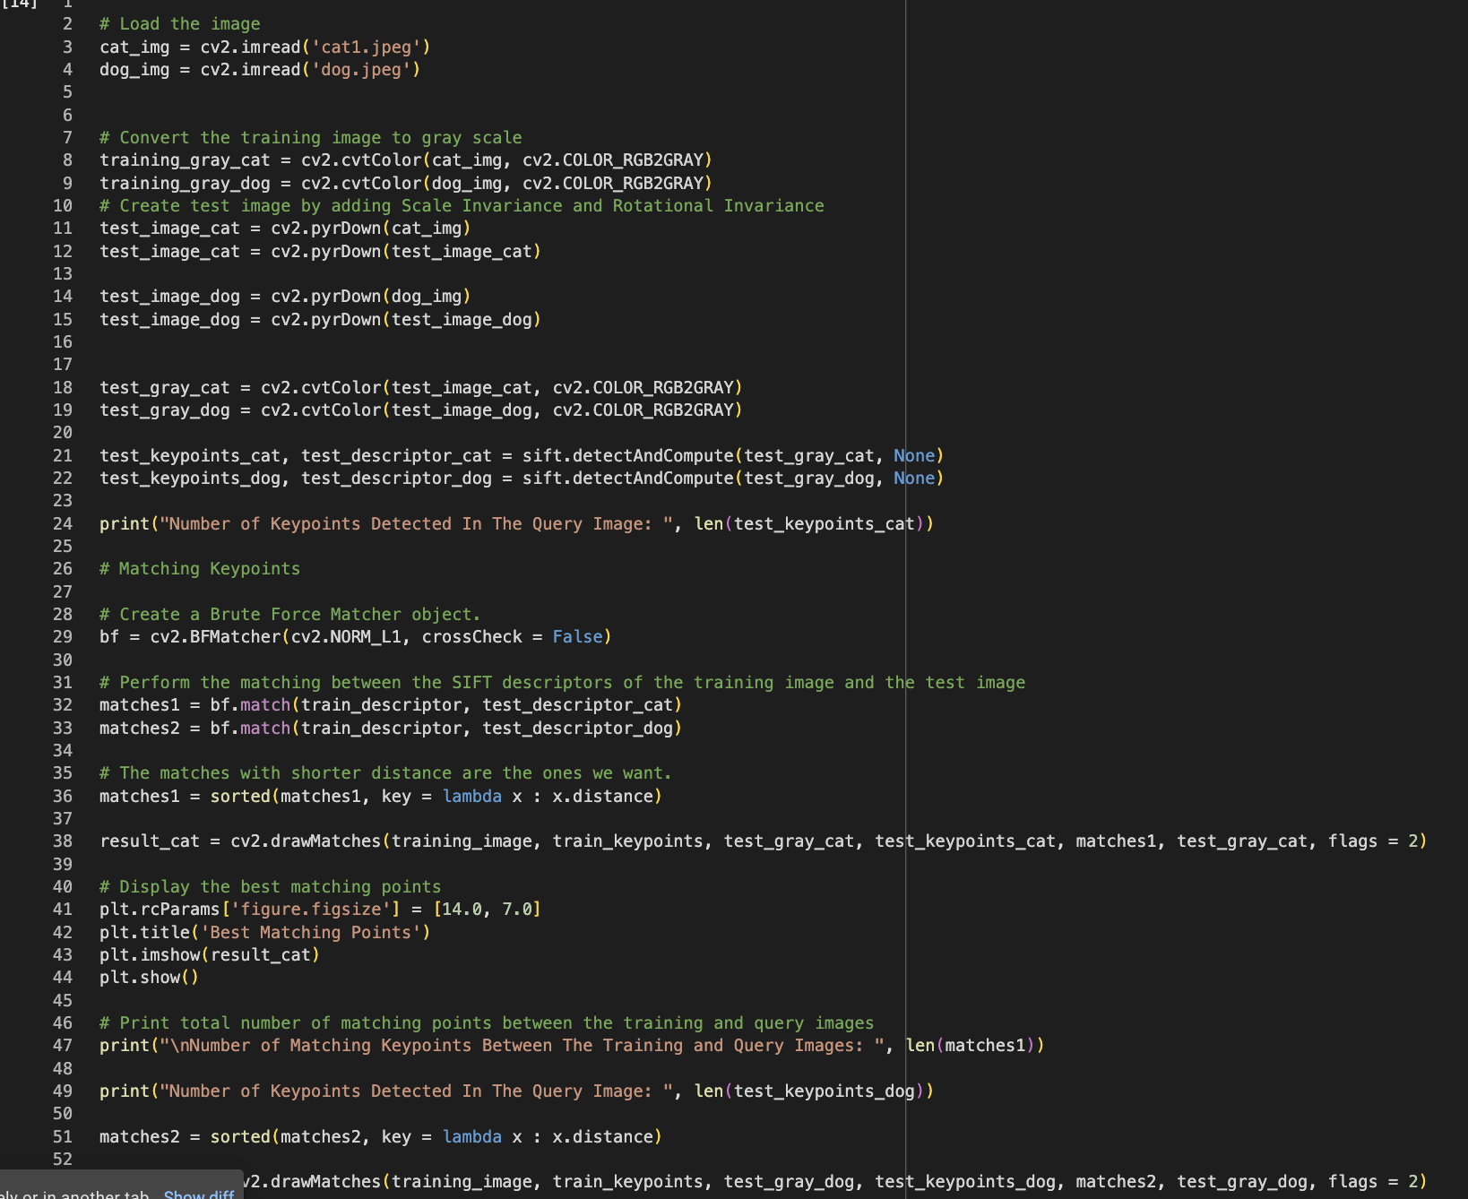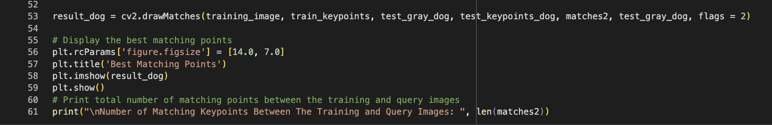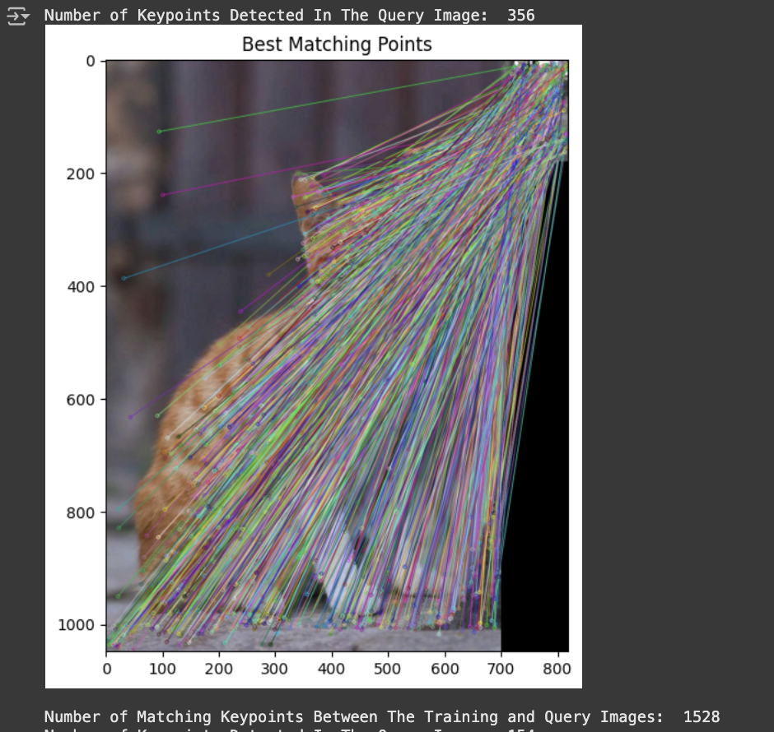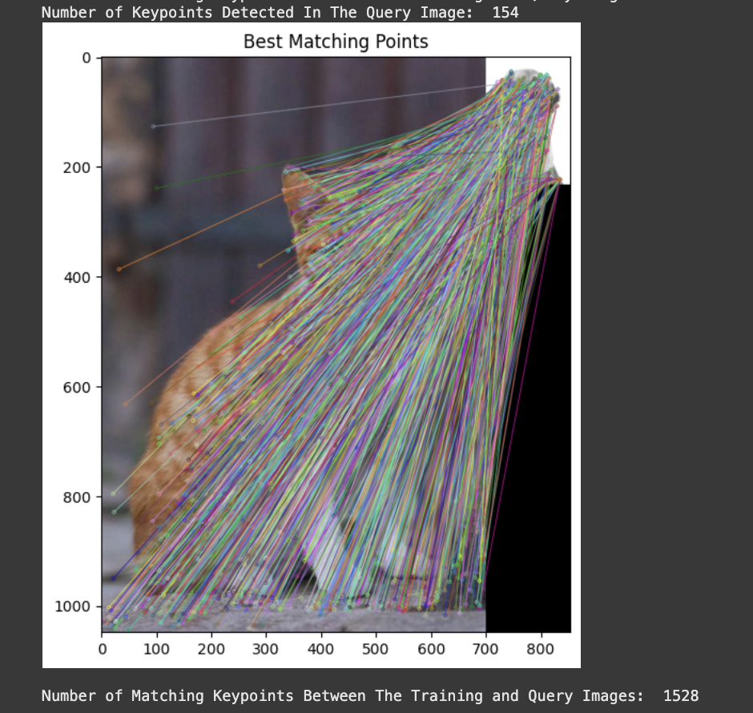

Short note explaining whether SIFT can handle such a devious disguise.

SIFT identifies keypoints based on texture and shape, not object recognition, so it may match similar features between a cat and a dog, even if they are different objects. It doesn’t "understand" the images and relies purely on geometric similarities. For true object recognition, more advanced models like CNNs are needed to detect object precisely.

**Question-03**

**Discuss the role of each layer in the architecture and why VGG-16 uses small filters (3×3).**

**Answer:**

VGG-16 is a deep learning model with a total of 16 layers. It has 13 convolutional layers grouped into five blocks, each extracting features from images. The first two blocks have 2 convolutional layers each, while the last three blocks have 3 convolutional layers each. These layers detect patterns like edges, textures, and objects. After feature extraction, 3 fully connected layers classify the images into categories. The design is simple yet powerful, with small 3×3 filters for efficiency and depth. This structure helps VGG-16 achieve excellent performance in image recognition tasks.